**Develop Coding: Assignment**

**Student Name:** *Sasha Valentine Simbisai*

For each question which includes ‘describe’ or ‘review’, write at least a paragraph worth of content to explain your answers. Include any other relevant evidence where appropriate, i.e. links or images.

**Q1. Describe the purpose of using IT in creating your website and how you will use IT to plan and carry out the necessary tasks. (How will you plan your website, what audience is it aimed at? How will your use of IT achieve the required outcomes in your plan?)**

*IT lets me realize my ideas more coherently. Planning tools like Project Boards and App Diagrams will help put concepts together in ways that are intelligible. Can this work, how will it work, what is needed – such questions can be addressed at the planning stage using these tools saving a lot of guess work and time. Some ideas will not be suitable for not only the project and time frame but for the proposed method in which I have to put together. Ironing these hurdles at the very beginning as quickly as possible ensures I have less iterating to do later on.*

**Q2. Describe methods, skills and resources needed to complete your website - explain what IT systems and software applications you need to be successful in your website project, and how you will use them (Describe at least one method, skill and resource needed to complete your website)**

*The Internet is a great source of information, to build my site I will first need templates or references. Then I will need research on similar projects to find the most effective and efficient application methods. I need to be analytical and competent in grasping concepts. I will also need to be innovative in adapting my idea to the method.*

**Q3. Describe the legal guidelines and risks that might impact your website project - how does GDPR and copyright affect website development?**

*Depending on whether it’s a business or personal website, key disclosure is required under law. For businesses this can be company identity and contact information. Users also have rights to consent to the use of their data. The website must by law also be accessible to anyone who needs it in accordance to the equality act as well as have the facility to protect personal data.*

*Copyright will be the most relevant measure to consider as all websites and their content are considered protected provided, they are original works, where if they not, it may be necessary to provide disclaimers as a deterrent to others stealing my works or my using of others with or without permission. Exerting your own right to copyright and respecting copyright belonging to others can resolve legal issues before they present themselves.*

**Q4. Review the ongoing use of IT tools you have used for your website and describe whether they are appropriate - what are the benefits and drawbacks of IT tools and systems used? (Are you happy with the tools you used?)**

*I used VS Code for writing code and testing, it was by far the most effective as it I was sable to preview the website as I was building. Time management was crucial for this project, the deadlines where shorter than previous, yet it involved a lot more creativity and was syntax heavy as opposed to logic -- I had difficulty settling on a concept for a few days so needed to be really efficient. Separating building and testing was not ideal.*

*Also heavily used was the Internet for research, by far the most powerful tool I could employ as I learned things outside of the course. I found other tools like Trinket for embedding a Python interpreter projects in HTML environments, I also navigated through YouTube for tutorials on realizing particular concepts like CSS styling. This provided me the opportunity to be really creative with my design and being practical with building simultaneously.*

*Other tools I relied on were the Apple Notes and Draw.io apps on my Mac and iPhone. I templated the body of my site using Notes, this is where I partialized sections and imported information they were going to contain, it also let me allocate a checklist for sections and areas and structure items in a directory type system using the indentation feature, this allowed me to keep track not losing my place during the planning stages. Most importantly I was able to work much faster and effectively than normal.*

*Slack was important to communicate with the class, there were a lot of web applications and tools shared colleagues had come across and familiarize; Moshphoto for example is a tool you can use to animate your backgrounds and make it stand out. Trinket is another that came from slack.*

**Q5. Describe how you would test your website to make sure it looks as intended. Describe what kind of files you used in your website and explain why you have chosen those filetypes. How can you test your website to ensure it is accessible to people with disabilities? Describe how you can overcome potential accessibility issues with your website.**

*VS Code has played a big part in my testing, it offers plenty of extension such as live preview for HTML and CSS. I can see the changes and effects of my code as I write it in the terminal. This is a local test on my computer, although it can help iron out issues I have noticed issues when hosting online, things like syntax that works in VS Code not working in a browser or embedded application, this has caused me to modify the code so that it is compatible. For example, when embedding my projects to Trinket, I was always getting errors because it cannot interpret the print(f’’{}) function, it requires I call on the .format(‘’,’’) method. Another problem I came across was background formatting where certain images would not fill the work space no matter what changes were made in the style sheet. Being able to preview my build live is the greatest tool I have had this project.*

**Q6. Describe ways to improve your productivity and efficiency throughout this project (how can you make sure you are using IT tools and systems in the most effective way?) If you could have been more productive or efficient, how would you implement this for a future project?**

*I have mentioned a few times effective multitasking using VS Code, my productivity peaked using this tool -- when I was a little behind I was able to catch up fairly easily thanks to simultaneous tasks in VS Code.. During the group project to build a Code Based Text Game using Python, I was unfamiliar VS Code extensions and wasn’t using any so I recognize the difference it has made to my turn around. Live collaboration was the closest thing however at times that created more setbacks than resolving issues.*

*On my Mac I run a custom resolution from a library I edited, this allows me to fully utilize the Retina Display real estate and so when I run applications, I always have two side by side in various combinations, this is how I consume and produce simultaneously. During the course a technique I actively used was having VS Code adjacent to Zoom, this is so when Liam or Ayesha where doing walk-through I was being practical and writing code. I was learning by rehearsal. One draw-back was that if I missed something I couldn’t go back and had to solve a related issue by either using the Internet or playing back recordings albeit this was rare. The advantage of me doing this was, I was taking detailed notes on the fly and adapting to the logic much faster by being practical in the moment I was receiving the information.*

*As I mentioned this technique was not as effective when going over CSS syntax, I understood the basics of elements and parameters however, when it came to alignment and sizing it was not as straightforward. It is possible an affinity for programming logic had me conditioned making it harder to adapt to CSS syntax on the fly but overall the logic was not too difficult to understand once gone over a few times.*

**Q7. Describe the final version of your website (what is the content and layout for each page?), assess the strengths and weaknesses and describe further improvements you can make to your website. Is the website fit for purpose? (did you achieve what you set out to do in your plan?)**

*My site is an interactive gallery of everything I have done throughout the course and my thoughts about programming.. It is designed with accessibility in mind so it is easy to navigate, it is not crowded but orderly and scalable. Its greatest strength I believe is it will keep visitors entertained, there are games to play and cool videos to watch. There is no image dumping and everything is carefully laid out to make it approachable. A weakness could be the color scheme, it’s a dark with white clear fonts however this may not be to everyone’s liking. I designed it with efficiency in mind as using white or lighter color schemes mean having to use more colors to make content legible. I tool a minimalist approach with the website but put of lot of detail into it, oxymoron? Some easter eggs are animations and techniques I had to work on for days just to get working. There are things I may add such as contact or social media links however they were problematic with some of the other elements, containers weren’t positioning correctly and elements were not formatting properly when applied with other effects. The Website is definitely fit for purpose. I did not want to over complicate things as too much can turn visitors away.*

**Q8. Take a screenshot of your website homepage working in two different browsers. (Make sure the GitHub Pages link is visible in the screenshot).**

*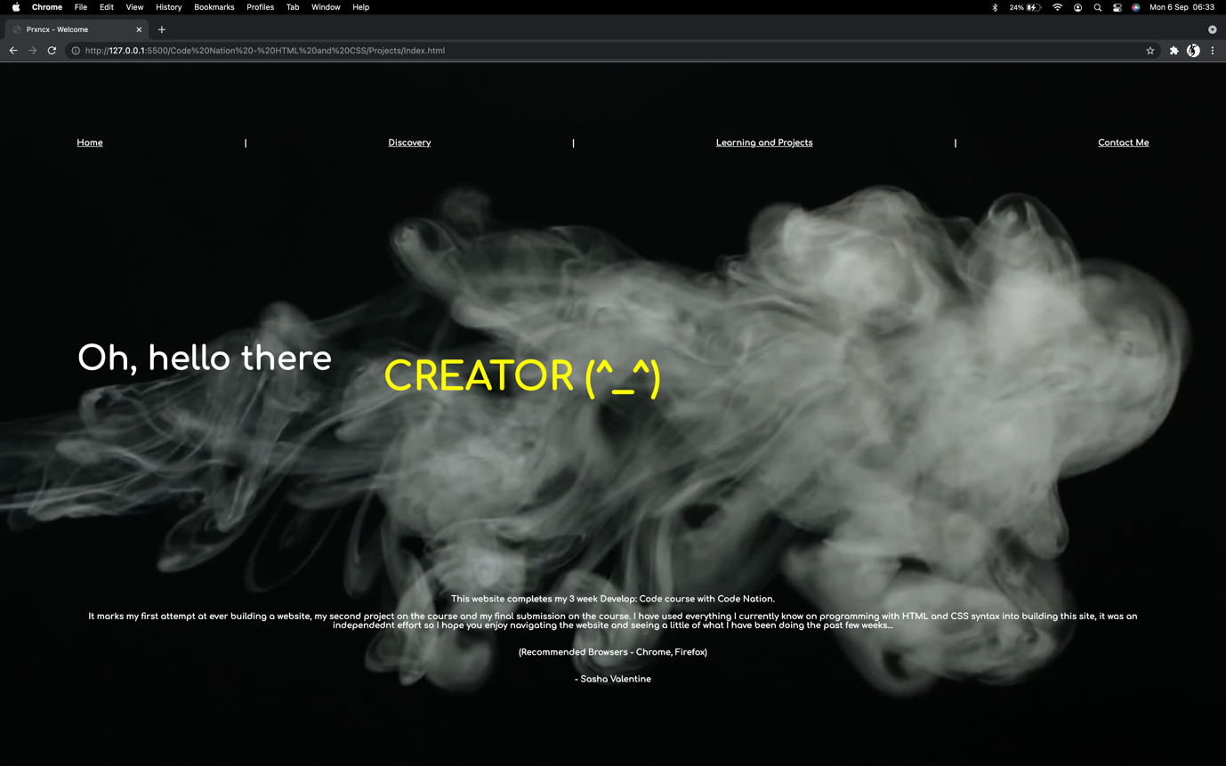***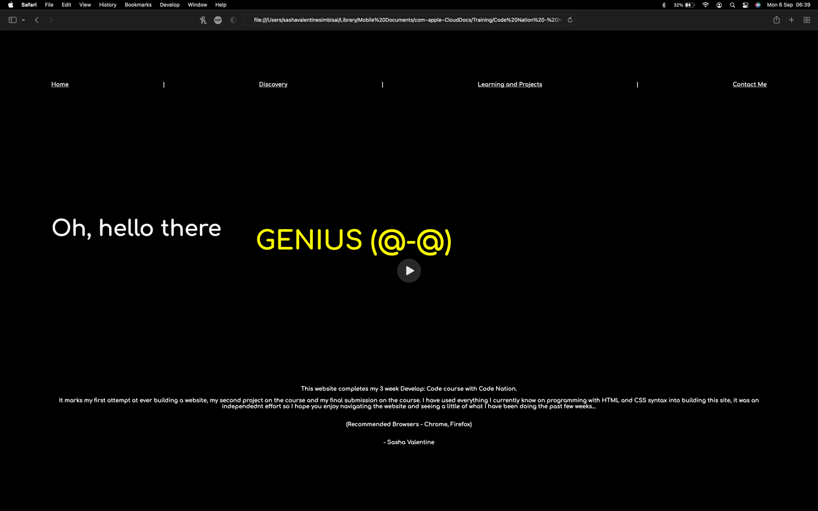**

|  |  |  |  |  |  |  |
| --- | --- | --- | --- | --- | --- | --- |
| For Code Nation/TLM reference | | | | | | |
| Develop: Coding - Assignment Mapping Document | | | | | | |
| Questions | Q1 | Q2 | | Q3 | | Q4 |
| TLM Criteria | 1.1.1, 1.1.3, | 1.1.2, 1.1.5, 1.1.6 | | 1.1.4, 1.1.7, 2.1.5 | | 1.2.1, 1.2.2, 1.3.1 |
| Questions | Q5 | Q6 | | Q7 | | Q8 |
| TLM Criteria | 1.3.4, 2.1.6, 2.1.7 | 1.3.2, 1.3.3 | | 1.2.3, 1.2.4, 1.2.5, 2.1.1, | | 2.3.1 |
|  | | | | | | |
| Website | | | | | | |
| TLM Criteria | 2.1.2, 2.1.3, 2.1.4, 2.1.8 | | 2.2.1, 2.2.2, 2.2.3, 2.2.4, 2.2.5, 2.2.6 | | 2.3.2, 2.3.3, 2.2.4 | |